PRACTICAL-3 REVISION OF POINTERS
Problem-1
Aim:- Write a program in C to implement arrays of pointers and pointers to arrays.
Theory:- In this we created an array of pointers where in the array addresses of all the number is stored. Then we created pointers to arrays. In this first we created an array of numbers. Then we created a pointer which pointed to the address of the array which is the same as aarray[0].
Code:-
#include<stdio.h>
int main()
{
int a=10,b=20,c=30,i;
int *arr[3]={&a,&b,&c}; //array of pointers
for (i=0;i<3;i++)
printf("%d\n",*arr[i]);
printf("\n");
int ar[3]={40,50,60};
int (*p)[3]=&ar; //pointer to array
for (i=0;i<3;i++)
printf("%d\n",(*p)[i]);
}
Output:-
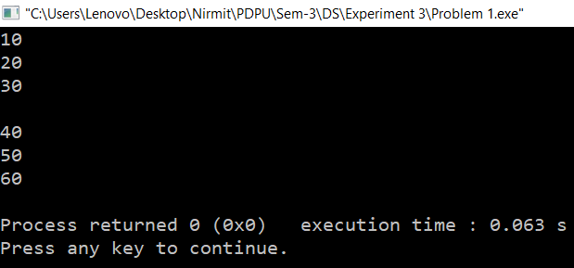
Time Complexity:- O(1)
Space Complexity:- O(1)
Problem-2
Aim:- Write a program in C to implement pointers to structures.
Theory:- First we created structure with name, roll number and marks. Then we created a structure s1 and a pointer which points to the address of s1. After that we took the details from the user and the printed them.
Code:-
#include<stdio.h>
struct Student
{
char name[20];
int roll_no;
int marks;
};
int main()
{
struct Student s1;
struct Student *ptr=&s1;
printf("Enter details:-\n");
printf("Enter Name:-");
fgets(ptr->name,sizeof(ptr->name),stdin);
printf("Enter Roll Number:-");
scanf("%d",&ptr->roll_no);
printf("Enter Marks:-");
scanf("%d",&ptr->marks);
printf("\nDetails of student:-\n");
printf("Name:- %s",ptr->name);
printf("Roll Number:- %d\n",ptr->roll_no);
printf("Marks:- %d\n",ptr->marks);
return 0;
}
Output:-
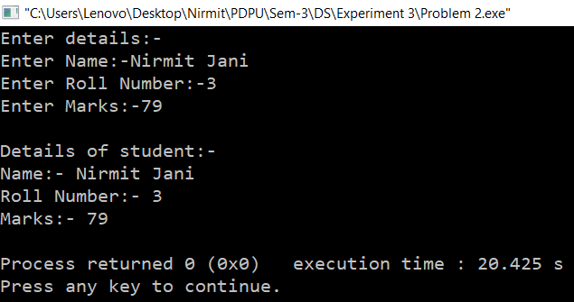
Time Complexity:- O(1)
Space Complexity:- O(1)
Problem-3
Aim:- Write a program in C to perform swapping of two numbers by passing addresses of the variables to the functions.
Theory:- In this first we created 2 numbers n1 & n2. After that we created two pointers which points to the two numbers. Then we swap the addresses of both the numbers.
Code:-
#include<stdio.h>
int main()
{
int n1=10,n2=20,temp;
int *ptr1=&n1,*ptr2=&n2;
printf("Before Swapping:-\n");
printf("Numbers:- N1=%d and N2=%d\n",*ptr1,*ptr2);
printf("Address:- N1=%d and N2=%d\n",ptr1,ptr2);
temp=ptr1;
ptr1=ptr2;
ptr2=temp;
printf("After Swapping:-\n");
printf("Numbers:- N1=%d and N2=%d\n",*ptr1,*ptr2);
printf("Address:- N1=%d and N2=%d\n",ptr1,ptr2);
return 0;
}
Output:-
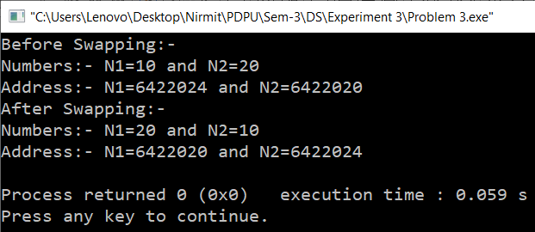
Time Complexity:- O(1)
Space Complexity:- O(1)

